GIT WORKFLOW

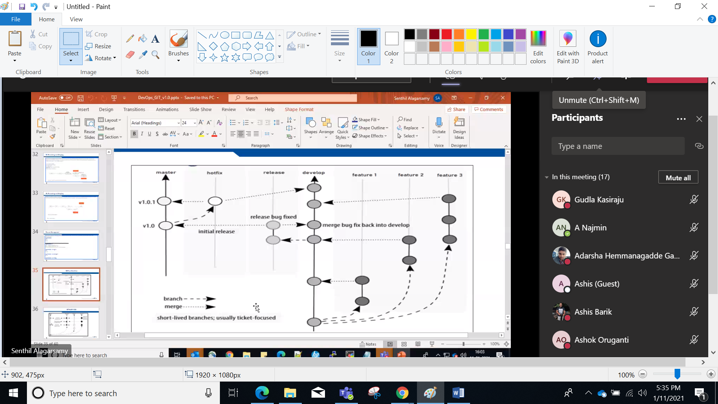

Long Live branch-------Master HEAD is always points to the origin/master where source code reflects PRODUCTION-RADY-STATE

-------Devlop bnach(Integration Branch)Latest delivery reflects to next release

Short Lived Branch--Feautre Branch,HotFix Branch,Release Branch

///////////////////////////////////////////////////////////////////

**Create file in master branch**

**Create Develop branch**

**Create Myfeature branch**

**Take some changes into myfeature branch then merge back to develop branch**

Mkdir workflow

Cd workflow/

Echo “I am in master branch”>file1.txt

Git add .

Gt commit –m “commit by master branch”

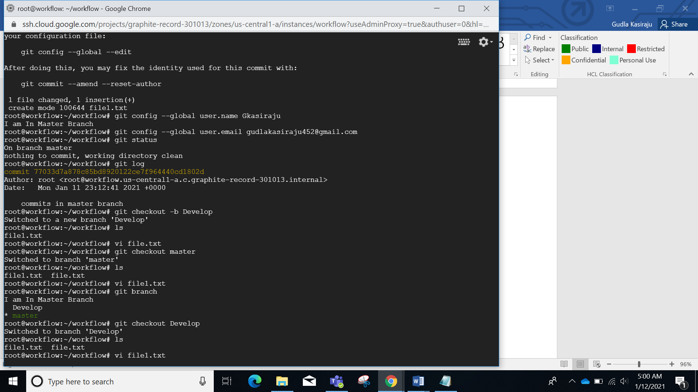

Git checkout –b Develop

Git checkout –b Myfeature

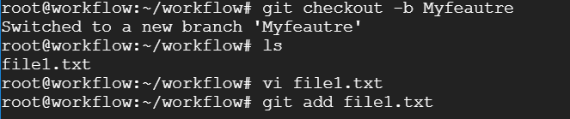

Open that file take some changes and commit merge back to develop

Vi file1.txt

Git add .

Git commit –m “Myfeature updated”

Git checkout Develop

Git merge –no—ff Myfeature

Git branch –d myfeature

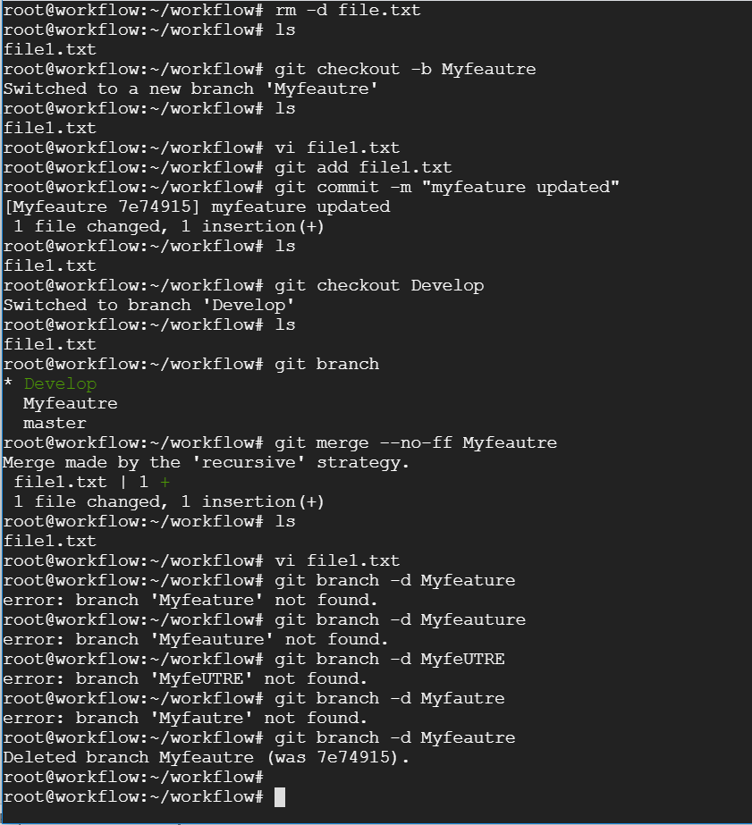

**Hotfix brnahc**

hotfixbrnach

from master branch

merge back to develop and master

create a hotfix brnach and fix the bugs

git checkout –b hotfx

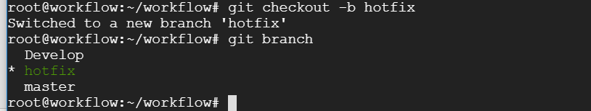

Merge to master

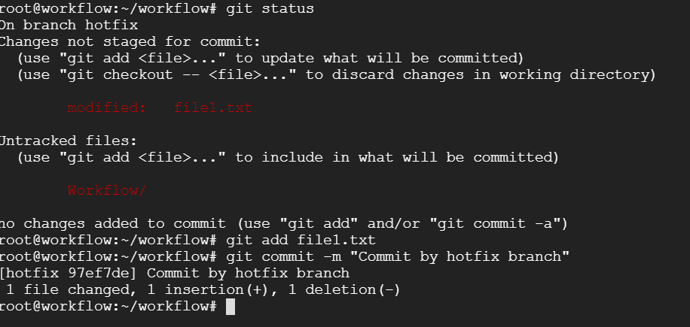

Merge back to master and Develop

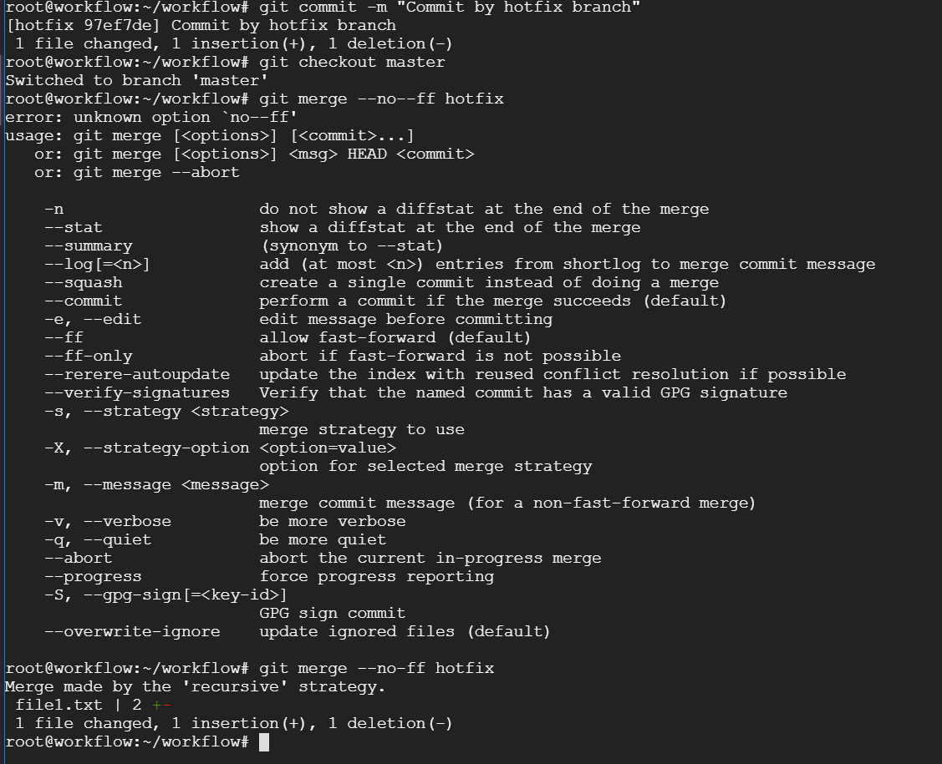

Merge back to Develop:

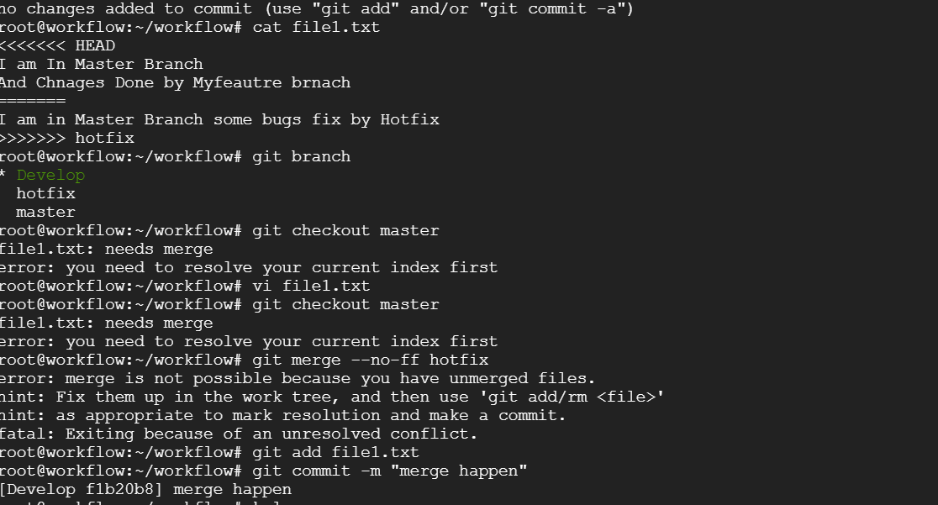

**Release Branch:**

Branch off from the develop

And merge back to both master and develop

Git checkout –b release

//commit the changes

Merge back to master

Git merge –no-f release

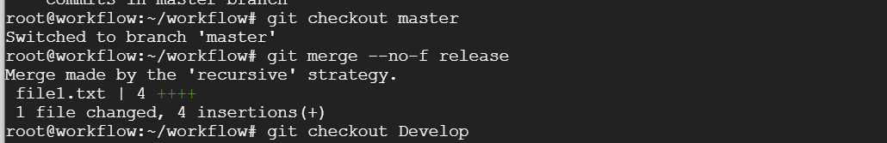

Merge back to Develop

Git merge –no-f release

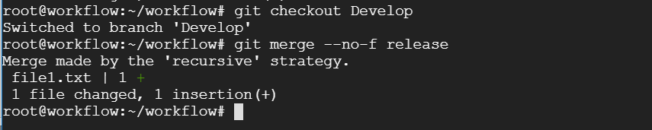

**GItHUB**

